

| **Utah Bridge Program**  **Co-Teaching Handbook & Orientation** |
| --- |

**TABLE OF CONTENTS**

1. **Mission & Purpose of the Bridge Program**
2. **The Bridge Program & the Two-Teacher Model**
3. **Characteristics of Effective Co-Teachers**

Co-teaching: What it is and what it is not

1. **Foundations of Co-Teaching:**

Getting Acquainted - Questions for Co-Teachers to Discuss

Clerical Tasks for setting up your Bridge Program team communication, calendar, and instructional resources folders

1. **Agreement and Commitment for Co-Teach**

*Before initiating a co-teaching relationship*

*Before planning sessions*

*Before lessons*

*During lessons*

*After lessons*

*Regularly during the year*

1. **Co-teaching Models**(options for how to structure the co-teaching lesson day)
2. **Effective Co-Planning**

*Positive Communication Strategies and Sentence Frames*

*Student-Centered Weekly Collaboration Meeting - Model Agenda*

*Communication that will damage your partnership*

1. **Dialogues to Strengthen the Partnership**

**Scenarios for Discussion**

**IX. Academic Support Plan (when a student is not maintaining a grade of C or higher) - Meeting guidelines and model steps)**

**Bridge Program Documents**

1. [**Bridge Program Fidelity Assurances**](https://drive.google.com/file/d/1ulJXlqypAuafEXz5reedwIKkQXtQci1H/view?usp=drive_link)
2. [**K-12 Proficiency Targets**](https://drive.google.com/file/d/17srkrXoEQgjvPXQvMHVMkpRZYtUZge2Z/view?usp=sharing)
3. [**Bridge Program High-Leverage Practices**](https://drive.google.com/file/d/1lo9DFl8Vyzu4mbX8cp6FS9KZYgtn0VnS/view?usp=drive_link) **(**Self-Reflection & Administrative Observation Tool): Program instructional priorities, program priorities & Co-teaching Assurances
   1. [College & Career Readiness](https://drive.google.com/drive/folders/1m_umxHdzIjh2o7jsn7DU20XwBAOZlT3A?usp=sharing) Folder-Mini-Lesson Plans
   2. [Community Building](https://drive.google.com/drive/folders/1emAvwvnnJA4QsCqbcpQe1pAnV94P5FTv?usp=sharing) Folder-Lessons and Prompts
4. [**Administrative Calendar**](https://l2trec.utah.edu/bridge-program/administrators/index-1.php)(instructors: note deadlines and supporting documents housed here for the November Early Enrollment Process)
5. [**Grade Calculation Worksheet**](https://drive.google.com/file/d/1YKye4AgUX9SapZ9y39G10ru8QbdP04AD/view?usp=drive_link)
6. [**University of Utah Accommodations for Bridge Program Students**](https://docs.google.com/document/d/1ILNJu_Y0POcNITtlGCzaxlv4mZTlgbyV83HoYhABQ90/edit?usp=drive_link)





| **Mission and Purpose of the Utah Bridge Program** |
| --- |

As a partnership between Utah’s six universities and the Utah State Board of Education, the Utah Bridge Program offers upper division early college coursework in language study to support access to bilingual, biliterate, and multicultural citizenship, meeting each student’s potential in college and career pathways.

| **The Bridge Program and the Two-Teacher Model** |
| --- |

**Courses, credit, and prerequisite**

Students enrolled in Bridge Program coursework enroll concurrently for 1.0 high school credit while simultaneously enrolling at the partner university and registering for 3.0 university credits.

Bridge courses are unique from other Concurrent Enrollment courses in Utah in that they award upper division (3000 level) university credit. Course numbers are 3116, 3117 and 3118. One course is offered statewide in a given academic year.

Students must meet the *course prerequisite* of scoring a 3 or higher on the AP Language or NEWL Portuguese or Russian test, with the test taken in grade 9, 10 or 11 of high school. Students may enroll in a Bridge course in grade 10, 11 or 12, may take up to three courses earning 9 total credits, and may enter the program at any of these years upon meeting the course prerequisite.

*In terms of teaching and learning, this means that in any given year, a course may contain a population of students with great diversity in grade level, language proficiency, maturity, and life experience.* *Instructional differentiation, scaffolding, and clear measurable goals are critical in order to help every student to progress in learning course content and in language proficiency.*

**Co-teaching and the Bridge Program Model**

As an upper division course, universities require that a qualified faculty member is hired by the university department to serve as the instructor of record, co-teaching with a highly qualified high school instructor one day per week on a semester schedule or rotating 1-2-1-2 days per week on a trimester schedule.

**The co-teaching partnership requires university and high school faculty members to “*make joint instructional decisions and share responsibility and accountability for the learning of all students, while at the same time building on the strengths of each involved educator to provide high quality instruction paired with needed specialized instruction*” (USOE Co-teaching Handbook, 2011).**  Co-teaching is an adaptable model, allowing educators to adjust and blend teaching skills to benefit students, teachers, and the school.

As stated in [**State Bridge Program Assurances**](https://l2trec.utah.edu/bridge-program/administrators/Utah%20Bridge%20Program%20Fidelity%20Assurances-202348.pdf):

* The high school instructor teaches on all days of the high school academic school year, and the university instructor co-teaches 1 or 1-2 rotating days per week, following the the high school academic calendar.
* Both instructors follow the high school academic calendar, and establish a monthly calendar to designate all co-teaching days for the school year.
* Both instructors actively teach and provide feedback/support to students on co-teaching days.
* Co-instructors also hold a weekly collaboration and planning meeting, ideally scheduled before or after the instructional period(s). In this meeting, instructors review lesson objectives, discuss student outcomes, and plan next steps to support student mastery of outcomes.
* After high school-led instructional days, the highs school instructor communicates with the university instructor, providing an update on what was taught summary of student mastery or needs for support.

The university and high school instructors work as a team to deliver instruction to a diverse group of students in the high school classroom. Instructors bring their unique training, specialization, and experience to the co-teaching partnership including.

* Skills, experience, and areas of expertise or focus may differ between university and K-12 career pathways. Together, instructors bring their areas of expertise to ensure that all students receive the support needed to interact with upper division university coursework and themes, and to succeed and grow in their language proficiency.
* University career pathways may bring expertise and specialization in content knowledge in the language, literature, and cultures of study.
* High school career pathways may offer specialized knowledge of pedagogy for instructional supports, scaffolding, and positive behavior support.
* Both teachers will have demonstrated a high level of proficiency in the target language.

State Bridge Program Assurances (excerpts): 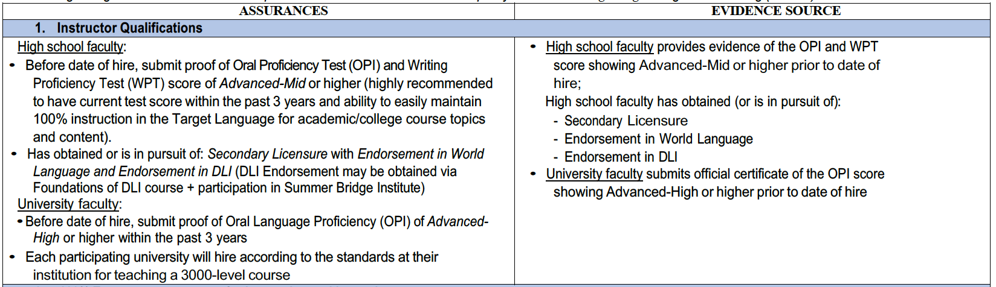

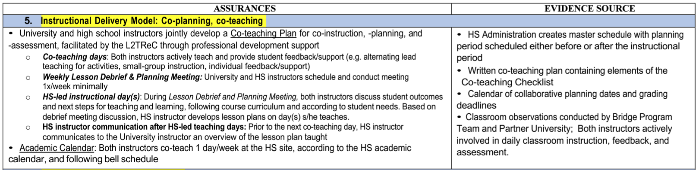

**Co-Teaching Responsibilities: University and High School Instructor Duties**

| **Mindset** | You are working together to help students to achieve higher proficiency levels in listening, speaking, reading, and writing.  **Co-teaching IS joint responsibility when teaching Bridge courses.** |
| --- | --- |
| **Purpose** | Two teachers share the students so both have equal responsibilities. Students should listen and respect both teachers equally. |
| Be flexible. Be adaptable. |

| **Tasks** | **College instructor** | **High school instructor** |
| --- | --- | --- |
| **Professional working attitudes** | 1. Address the differences and issues privately. Avoid conflict in front of the students. 2. Courteous language is expected for communication. | 1. Address the differences and issues privately. Avoid conflict in front of the students. 2. Courteous language is expected for communication. |
| **Scheduling** | Create and share weekly schedules prior to the school starts. Example: Marty”s Schedule. | Follow and communicate with co-teachers closely. |
| **Co planning** | 1. Prepare the folder of all teaching materials with all high school instructors. 2. Weekly meeting after class or online to communicate the learning objectives then decide what to teach and how to teach. 3. Promptly communicate all changes made in teaching materials. 4. Create the co-teaching lesson plan on co-teaching days; share lesson plan 2-7 days prior to co-teaching day; choose lesson sections to alternative lead. 5. During team meetings: Create an agenda, stick to an agenda, and end with agreement on a “to do” list for next steps. | 1. Read and be ready to lead instruction on all aspects of the Scope-and-Sequence and supporting documents. Review Scope-and-Sequence frequently. 2. Be ready to meet and actively participate in discussion with your co-teacher (lesson plan, pedagogy, co-teaching strategies, assessment). 3. After the lesson is sent for the upcoming co-teaching day, suggest lesson sections to alternate lead or suggestions for pedagogy. 4. Promptly communicate all changes made in teaching materials. 5. Communication after the HS instructor teaches lessons: send university instructor a quick update of what was covered and where to pick up. |
| **Canvas** | 1. Assignment names in English. 2. Must communicate clearly and promptly with both college and high school instructor when creating assignments and rubrics on Canvas. | 1. Assignment names in English. 2. Must communicate clearly and promptly with both college and high school instructor when creating assignments and rubrics on Canvas. |
| **Assessment** | 1. Must use Bridge rubrics when grading UPA writings, presentations and gallery walk/socratic seminar. 2. Inform high school instructor about grade changes and update. | 1. Must use Bridge rubrics when grading UPA writings, presentations and gallery walk/scoratic seminar. 2. Regularly update and insert grades for both high school and high school grading systems. 3. Inform college instructor about grade changes and update. |
| **Classroom management** | 1. Both instructors communicate and agree upon **expectations, routines, and incentives**. 2. Teachers should support each other when implementing classroom procedures. Address and discuss differences afterwards. | 1. Both instructors communicate and agree upon **expectations, routines, and incentives**. 2. Teachers should support each other when implementing classroom procedures. Address and discuss differences afterwards. |

| **Characteristics of Effective Co-Teachers** |
| --- |

The development of a co-teaching relationship represents a significant change in the working conditions and day-to-day activities of school professionals, most of whom have historically worked independently. As they initiate co-teaching relationships, professionals should consider the defining characteristics of co-teaching and their own professional strengths. Specifically, instructors developing new partnerships should be willing to:

* + Share their vision and commitment to co-teaching with colleagues
  + Engage in collaborative planning with parity
  + Identify clear roles and responsibilities
  + Establish mutually agreed-upon classroom procedures
  + Design lessons and assessments using baseline data, differentiation strategies, and backward design
  + Self-assess and set professional practice goals to meet student needs and to further develop skills in co-teaching
  + Actively participate in professional learning individually and in communication with colleagues

| **Co-teaching: What it is and what it is not** | | |
| --- | --- | --- |
|  | Co-teaching **IS** joint responsibility for | Co-teaching is **NOT** |
| **Planning** | Both instructors meet regularly and plan collaboratively using backwards design to meet course and unit objectives and use student data to inform planning. | One teacher assumes responsibility for all planning and instruction, or teachers compartmentalize responsibilities in a way that does not allow for collaboration. |
| **Instruction Delivery** | Both instructors engage in the teaching and learning process during instruction regardless of the choice of instructional model. | One instructor takes responsibility for lesson delivery and the other disengages or performs unrelated tasks. |
| **Assessment** | Both instructors participate in assessing daily lesson outcomes and provide feedback on student production and progress. | One instructor assumes responsibility for all teaching and the other for all assessments. |
| **Classroom Management** | Both instructors communicate and agree upon **expectations, routines, and incentives**. | Each instructor has different techniques for maintaining student engagement and incentivizing use of target language. Instructors use competing management techniques. |

| **Foundations of Co-Teaching:**   * **Getting Acquainted - Questions for Co-Teachers to Discuss** * **Clerical Tasks for setting up your Bridge Program team communication, calendar, and instructional resources folders** |
| --- |

As teachers begin to co-teach, partners should discuss their responses to the questions and statements below during an initial planning session. The information gleaned from such a discussion assists teams in getting to know each partner’s teaching style and preferences. **(BOLD indicates priorities for discussion prior to the first day of class.)**

1. **What do you see as your greatest strengths as a teacher?**

**What assets via your background and training do you bring to this position?**

1. **What are your classroom expectations?**

**- How/when will you develop and discuss these with input from your students?**

**- What Positive Consequences will you set up for students to reward when they succeed and follow them? Will you get student input on Positive Consequences or will you dovetail with school systems of rewards? What are these?**

**- What negative consequences are in place for not following them?**

1. **What are some of your “pet peeves” (things that bother you) in the classroom?**
2. **What are your classroom management procedures and routines for:**
   * **starting class**
   * **maintaining target language use only**
   * **seating chart or other tool for university instructor to get to know and use student names during class**
   * **use of cellphones in class**
   * **submitting, grading and recording assignments**
   * **posting learning outcomes**
   * **excusing for restroom, nurse, school counselor, or other related services**
   * **ending class**
3. **How will we coordinate and maintain records of grades and progress?**
   * **University Canvas Grades (weekly)**
   * **District grade book (weekly)**
   * **Written feedback to students**
   * **Ongoing formative assessments (e.g. Diagnostic Writing Cycle)**
   * **Other (specify)**
4. **How will we calculate** [**grading period, semester/term, and yearly grades**](https://docs.google.com/document/d/13O2sYZsAcBMzcaIYuprg5QfbvYNtGMMhZa1p90Vm24o/edit?usp=sharing)**? (See link for Utah Concurrent Enrollment Bridge Program Guidelines and Worksheet for final grade calculation.)**
5. **How will we coordinate communication with families so as to include both instructors? When will we communicate with students and families?**
6. **What day/time will we meet weekly to plan for co-teaching?**
7. **How will we share planning, preparing, teaching, and evaluating responsibilities?**
8. **How will we build trust and maintain confidentiality in our classroom?**
9. **How are we going to finalize our weekly Pacing Guide for the scope and sequence?** 
   * **Daily (formative) writing and speaking practice**
   * **Focused feedback & sharing progress with students (e.g. Diagnostic Writing goals and feedback cycle)**
   * **Tests**
   * **Quizzes**
   * **Homework assignments**
   * **Projects**
   * **Oral reports**
   * **Other (specify)**
10. How will we make decisions regarding use of classroom space (whiteboard space, information posted on walls, computer placement, seating arrangements)?
11. How do you plan lessons, units, field trips, tests, etc.? How closely do you follow your plans?
12. How do you provide for varied student needs during a lesson?
13. What noise levels do you permit in your room? How do you “manage” noise levels for engagement and learning?

Adapted for the Utah Bridge Program from “Planning for Effective Co-Teaching: The Key to Successful Inclusion,” by C. Walther-Thomas, M. Bryant, & S. Land, 1996, *Remedial and Special Education, 17*(4), pp. 255-265.

| **CLERICAL TASKS for setting up your co-teaching calendar, teaching resources, and communication** |
| --- |

* **Create your team’s shared Googledrive Folder.** Make sure everyone who needs access knows where it is and is able to be an active editor/participant.
* **Create your co-teaching calendar** for the term and for the year, and publish it in your shared Googledrive Folder. This is your commitment to your partner instructor. [Here is one [Template](https://docs.google.com/document/d/1f1GQHmkHpgi0jVQ9htSHAsRVeUm3YFRTLRWlFIa0IC4/edit)] Share your calendar with: department chair, principal and Bridge Coordinator.
* **Set and commit to your weekly collaboration and planning time.** What day/time will it be? (This must be minimally 30 minutes and must be during the HS teacher’s contract time, according to the Utah Teacher’s Union. I.e., it should not be during lunch or outside of contract hours.)
* **HS-led instructional days document:** How will you communicate with your university partner teacher regarding teaching and learning on the days where the HS teacher leads instruction?

Recommendation: Create a Googledrive document to write a *brief, bulleted* summary of teaching and learning on HS-led instructional days. Complete this by the end of each instructional day when the HS instructor leads instruction.

* Objectives, Content & Tasks: Recap the lesson’s content objective and language objectives. Briefly summarize/bullet the main content and tasks of the lesson
* Outcomes- What were students were asked to do/produce: Summarize what you expected students to produce/do as evidence of learning, how well students mastered the task/outcome, and what challenges students had in accomplishing or mastering this task.
* Possible next steps: If appropriate, suggest next steps or how the university instructor might pick up where you left off. State or suggest deadlines as needed for course pacing, for student feedback, or grading.

| **Agreement and Commitment for Co-Teaching (“Our Contract for Co-teaching”)** |
| --- |

It is the responsibility of co-instructors to work together collaboratively and maintain a respectful professional relationship. Co-teaching teams may want to formalize certain aspects of their relationships by establishing **ground rules or contracts**. The following may serve as a starting point for team members to determine how they will work together.

# Before initiating a co-teaching relationship, I agree to:

* Value and respect the confidentiality of our relationship
* Prioritize strong communication including meeting weekly to plan co-teaching
* Work to resolve conflicts that naturally occur
* Divide the workload equitably to ensure the success of our work together
* Adhere to the co-teaching calendar, communicate emergencies as decided on by

the team, and reschedule university instructional days missed.

* Other (specify)

# Before planning sessions, I agree to:

* Review curriculum (scope and sequence) and establish preliminary content goals
* Consider student needs and present levels of performance
* Reflect on previous lessons
* Other (specify)

# Before lessons, I agree to:

* Complete agreed-upon tasks in preparation for co-teaching
* Review and flesh out daily content and language objectives
* Notify my partner of changes in the schedule
* Other (specify)

# During lessons, I agree to:

* Respect my co-teaching partner and give him/her an opportunity to lead the instruction, as appropriate
* Be flexible and willing to adjust plans to meet student needs and common learning goals
* Check with my partner before making major adjustments to lesson plans
* Other (specify)

# After lessons, I agree to:

* Reflect on student outcomes
* Plan next steps toward learning goals
* Fulfill follow-up responsibilities
* Other (specify)

# Regularly during the year, I agree to:

* Discuss the co-teaching relationship
* Provide and accept suggestions that will enhance the co-teaching relationship and improve student learning
* Discuss any concerns that arise in the co-teaching relationship with partner teacher before seeking outside support
* Other (specify)

| **Co-Teaching Models**  **(Goal: for each week’s co-teaching lesson, discuss and designate a variety of co-teaching strategies that best fit the learning activities and student needs)** |
| --- |

Notes:

* It may be most efficient on the one co-teaching day per week that the university instructor takes the role of lead instructor that day, or instructors can create their lesson plan together and designate the co-teaching strategy to use in a given segment of the day’s lesson.
* Whichever approach you take, team to plan ahead and specify how *both instructors will contribute and support students*.
* Teams should consider when to designate parts of the lesson with *small-group instruction* to optimize teacher-student feedback and engagement.
* ***The university instructor cannot be left alone in the classroom.***

The following are some possible co-teaching models taken from the Utah Co-Teaching Handbook. <https://drive.google.com/file/d/1ePc1EzDz2lTSzDIjup_-tGI_YXpFxVCy/view?usp=share_link>

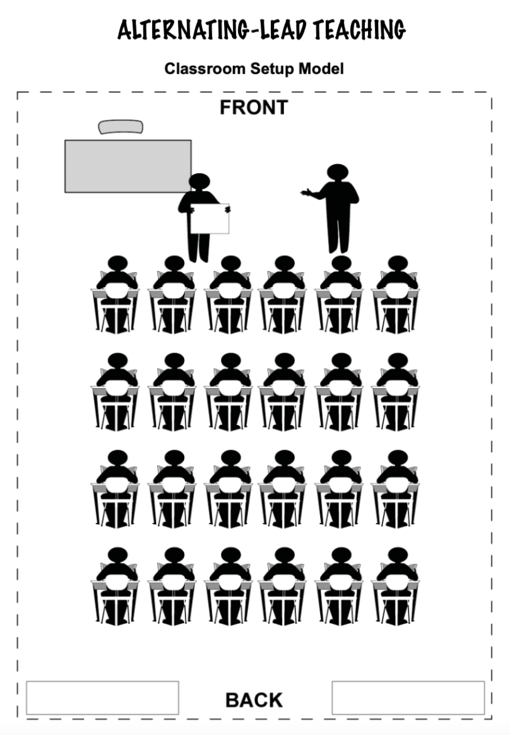

**ALTERNATING-LEAD TEACHING MODEL TIMELINE:**

* + **2-6 days before next co-teaching day**:
    - University instructor develops a detailed lesson plan or PPT _______ (between 2-6) days before the next co-teaching day. Both teachers must discuss and decide how many days prior to the next co-teaching day the draft lesson needs to be sent to the HS teacher.
    - HS instructor provide suggestions on which parts of the lesson they will take the role of lead instructor.
    - HS instructor provides suggestions on pedagogical strategies and activities.
    - Both instructors respond to agree on final lesson plan structure and co-teaching roles.
  + **Before co-teaching lesson:** Communicate sick days, planned days not teaching, or emergencies as EARLY as possible. For emergencies the morning of class, text/call immediately.
  + **Before 1st period**: Prepare and have all paper or lesson materials ready.
  + **Day of co-teaching**: University instructor is responsible for **arriving minimally 15 minutes before the start of the first class**.
    - The **PPT** is displayed; **College Canvas course** open and ready to reference during the day’s lesson.
    - **Learning Objectives** are posted on the whiteboard and PPT before students enter (refer to whiteboard objectives during the lesson)
    - Organize all **teaching materials**.
    - **Lesson check-in**: Co-teachers run through the details and transitions of the day’s lesson, or discuss any possible changes that had not been anticipated.
    - Be ready to **greet students at the door**- welcome students or chat with them, making a personal connection as they enter.
* **During the lesson:**
* **Weekly Co-planning Meeting (see Sample Agenda, below)**

| **WEEKLY CO-PLANNING MEETING - Sample Agenda**   1. RECAP OF OBJECTIVES: What were students supposed to know and be able to do (content objectives, language proficiency objectives) *(E.g. “Let’s recap what we hoped students would know and be able to do today…we wanted them to…”)*? 2. STUDENT MASTERY: To what extent did students meet the learning objectives?  * Where were students doing great, showing evidence that they mastered objectives? * Where did students struggle?   + Looking directly at student outcomes and products we designed for this lesson, what evidence do we have of student achievement of learning goals?  1. INTERVENTION: Are there individual students who are struggling?  * Are there students not submitting work, low grade, attendance problems, behavior, target language usage, homework, or other issues? * How are we going to help?   + What communication with students and parents is necessary?  1. NEXT STEPS: What should the next steps be?  * Content focus * Language proficiency focus * What will students DO, practice and produce next to demonstrate learning of objectives? Where do they need special support? Are we on track with pacing for the big picture of the unit plan and culminating project? * What teaching methods might be most effective to help us move forward with our unit plans and student learning goals? What grouping strategies with two teachers might we use? * How are we going to assess learning goals and provide feedback? Who will enter grades this week–in Canvas, in the HS Gradebook? What formal feedback needs to be returned to students this week; by what date? What communication do parents need?  1. DEADLINES/RESPONSIBILITIES: Who is responsible for what pieces? What deadlines for feedback or for student work will happen this week? |
| --- |

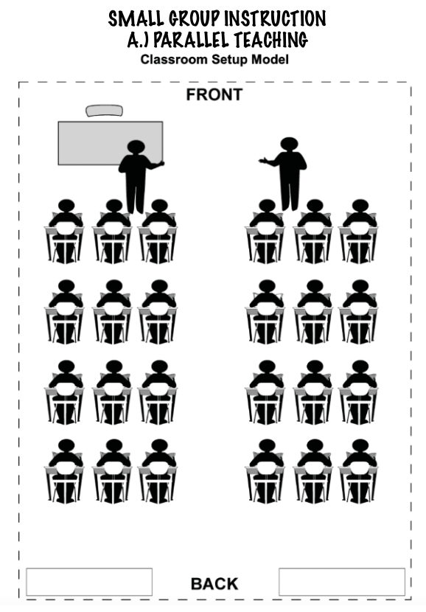

**SMALL GROUP INSTRUCTION**

**A.) PARALLEL TEACHING**

**(Recommended use: FREQUENT)**

Teachers are both teaching the same portion of a lesson, but they divide the class into equal groups and teach simultaneously. This allows for more support, more feedback, and greater participation from students. Use for portions of the lesson where students are actively producing language and may benefit from increased feedback.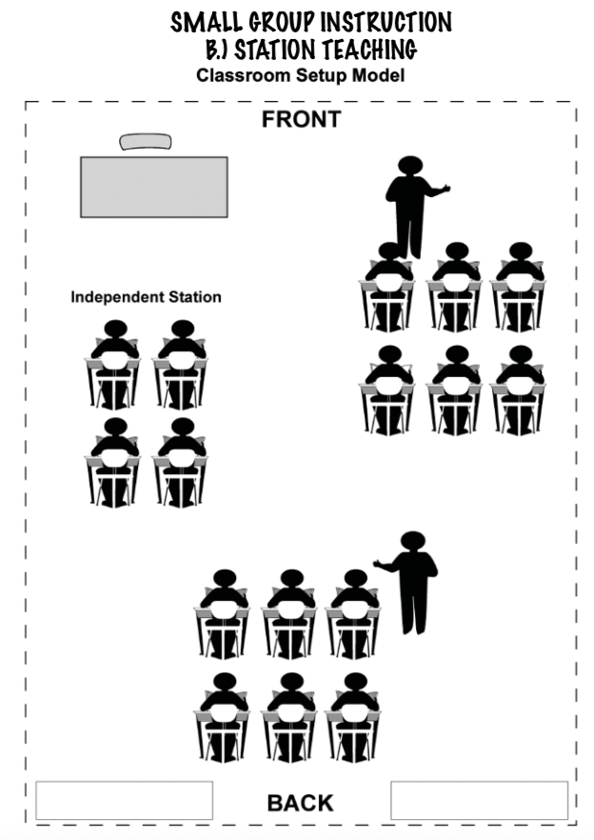

**SMALL GROUP INSTRUCTION**

**B.) STATION TEACHING**

**(Recommended use: FREQUENT)**

Teachers divide content/task and students. Each teacher then facilitates, guides, or explicitly teaches a portion of the lesson to one group and subsequently repeats the instruction for the other group. A third or fourth “station” can give students opportunities to work independently, accessing peer tutoring and technology.

**SMALL GROUP INSTRUCTION**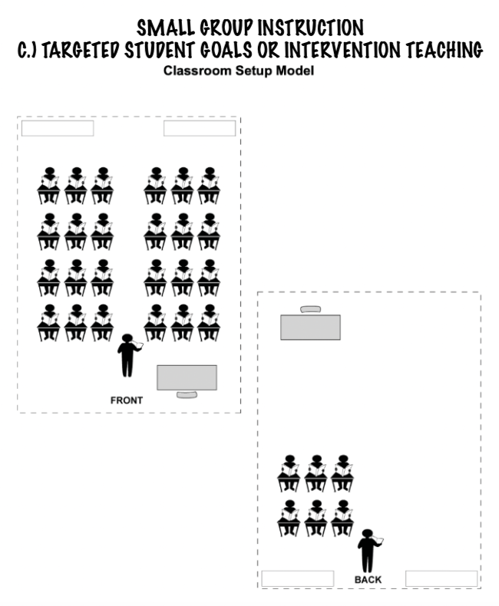

**C.) TARGETED STUDENT GOALS OR INTERVENTION TEACHING**

**(Recommended Use: Limited portions of a class period)**

One teacher takes responsibility for the large group while the other works with a smaller group. The smaller group is not a permanent subset of the class and can be pulled aside for pre-teaching, enrichment, tiered intervention, to develop a special activity to present to the remainder of the class, or for presentation of content using an alternative method or strategy. (E.g. students who are behind because they were at a school sporting event or competition, students who did not turn in a 1st draft and need guided help)

| **Effective Weekly Co-Planning Meetings & Communication** |
| --- |

**It is expected that co-instructors hold weekly planning meetings and that this time is protected and honored.**

The goal of a productive and respectful collaborative meeting is to focus on discussing, analyzing, and recapping the **extent to which students were able to master content and language objectives that day/week in order to plan the next week’s lessons in a way that meets student needs.**

**Positive Communication Strategies & Sentence Frames**

**Discussion and language each teacher uses during the collaborative planning meeting should seek to understand the student experience, or specifically the mastery and struggles or needs for support. *The meeting should not focus on the successes or faults of a teacher.***

*Examples to make suggestions that do not blame or insinuate fault:*

***“I wonder if…”***

***“What about…”***

***“Could we…”***

*Examples of building the relationship by showing appreciation (be sure to include one*

*every day of co-teaching):*

***“I loved when you…”***

***“Thank you for…”***

***‘We did it! OUR lesson accomplished…”***

*Examples of language centered on students’ response to the lesson:*

***“I felt that the students were struggling or lost during…*** *this part of the lesson.”*

***“I noticed that one table group…*** *was talking a lot in English.”*

***“I noticed that students struggled to produce…****much language during the class period.”*

***“I noticed that students seemed frustrated during [x part] of the lesson.******I wonder if…****they were confused about the directions…****I wonder if*** *students were confused about the vocabulary…****I wonder if students needed*** *one more step of practice or modeling in order to be able to do that task at the level we were hoping.”*

***“I’m not sure if…*** *our objectives were clear or motivating to the students today.* ***What about*** *… to try next time?”*

***“How could we structure that differently next time…*** *we use that activity/method?”*

***“What should we do next to help students…*** *be able to feel confident about the task?”*

***“A teacher I work with shared the way they approached this challenge/problem. Would this work…?”***

**Communication that will kill your partnership**

“The Four Horsemen: Criticism, Contempt, Defensiveness and Stonewalling”

- Dr. John Gottman, psychologist

The Gottman Institute

[**https://youtu.be/1o30Ps-_8is**](https://youtu.be/1o30Ps-_8is)

1. **Criticism** - Criticism is different from offering a critique or voicing a complaint. Critique and complaints are about specific issues; criticism is an attack.

Antidote: Try talk using “I” statements, be specific about the problem or issue, and focus on positive needs (of students).

1. **Contempt** - When we communicate with contempt, we are truly mean–we treat others with disrespect, mock with sarcasm, ridicule, call them names, and mimic body language such as eye-rolling or scoffing. The target of contempt is made to feel despised and worthless. Contempt assumes moral superiority.

Antidote: Build a culture of appreciation; find and voice gratitude for positive actions.

1. **Defensiveness** - Defensiveness is typically a response to criticism. We’ve all been defensive, sometimes when we feel unjustly accused. We may fish for excuses and play the innocent victim so that our partner will back off. Being defensive escalates the conflict.

Antidote: Acknowledge your partner’s perspective or criticism.

1. **Stonewalling** - Stonewalling is usually a response to contempt. Stonewalling occurs when the listener withdraws from interaction, shuts down, or stops responding. Rather than confronting the issues with your partner, people who stonewall can make evasive maneuvers such as turning away or acting busy. It is a result of feeling physiologically flooded, and when we stonewall, we may not be in a state where we can discuss things rationally.

Antidote: Try to take a break a to help stop feeling flooded (and then return to focus on

student learning and support).

**Communication Flow Chart**

**When you have a concern:**

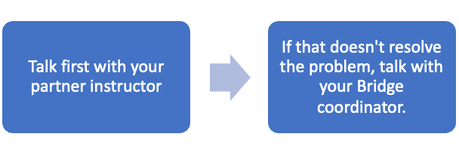

| **Dialogues to strengthen the partnership** |
| --- |

* **Whose school is this? Whose classroom is this? Whose kids are these?**

(i.e. how does the university instructor respect the connection to the home school while also being welcomed and integrated into the classroom and into the community; how do instructors build the message to students and parents that they are partners and both serve students equally while the university instructor is getting to know the high school and the community?)

* **What makes this a university class? How do we serve high school students to succeed in a university class?**
* **What is a good use of time for the university instructor to build relationships with students when the instructor is there only one day each week?** (e.g. a picture seating chart to learn students names, individual conferences, supporting group work, question-of-the-day to get to know students’ personal life, College&Career Questionnaire)

| **Scenarios for Discussion**  **Building the foundations for successful co-teaching and professional relationship** |
| --- |

**Scenarios for Discussion:**

1. I see students falling asleep during a long PowerPoint presentation. How do I bring up that I’d like to get our students more engaged and awake?
2. My partner teacher discussed a concern with the Bridge coordinator without bringing it to my attention first.
3. My partner teacher doesn’t make time for weekly meetings or uses the time to talk about issues unrelated to teaching.
4. My partner teacher doesn’t respond to emails in a timely manner.
5. My partner teacher didn’t inform me of what was covered in the last lesson(s) or what will be taught in the next lesson.
6. My partner does not enforce the classroom management policies that we agreed upon: no English, use of phone, etc.
7. I feel like my partner teacher is competing with me for the favor of the students.
8. My partner teacher argues, criticizes or disagrees with me in front of students.
9. My partner teacher is disengaged from the lesson while I am teaching (doing other things).

**EVERY YEAR AT THE SUMMER BRIDGE PROGRAM INSTITUTE, THE FOLLOWING SHALL BE DISCUSSED AND OPERATIONALIZED BY EVERY TEACHER PARTNERSHIP:**

| **Foundational Co-Teaching Communication “To do” list:** | **Action plan:** |
| --- | --- |
| **1. Create a Googledoc folder** to house ALL instructional materials. Everything must be visible and accessible to co-teachers in the case of an emergency like a sickness and unplanned absence. | **Link:** |
| **2. Create a Googledoc shared calendar** based on each university instructor. This must be shared with all partner instructors for that university instructor. Additionally, share with the department chair and the Bridge Program Coordinator. | **Link:** |
| **3. Create a Googledoc Record of Instruction:** this is an ongoing brief bulleted report of what is taught every instructional day, specifically for the HS instructor to inform the university instructor where they left off each day they led teaching. This creates continuity of teaching and learning. | **Link:** |
| **4. Send university co-teaching lesson to co-teacher prior to day of instruction:** Discuss and stick to a target deadline each week for the university instructor to send their lesson draft to the HS partner teacher(s) to review, and for them to be ready to lead portions of the shared instructional day. (For example: University instructor send PPT outline to HS partner teacher 1 week prior to day of instruction, partner teacher respond with questions/comments and ideas for potentially creating interactive activities to add to the structure of the lesson prior to the day of the lesson.) | **Agreed on timeframe:** |
| **5. Weekly collaboration meeting:** Solidify and commit to the planning period every week. Reference the model Collaboration Debrief Meeting Plan from the co-teaching handbook to guide meetings until instructors feel confident with the meeting format. | **Weekly collaboration meeting period/time:** |
| **6. University sick days/absences or late arrival (emergencies day of teaching):**   1. Document all days absent on their shared calendar. 2. Additionally, as early as possible, communicate to a.) their partner teacher, who will be shouldering the burden of teaching in their absence and b.) their department chair who is their supervisor. 3. If the univ instructor is absent or late, they are responsible for:   i.) sending a sub plan and  ii.) rescheduling/making up the class the following week. | **How will you communicate with partner teacher if there is sickness or an emergency?** |
| **7. High School sick days/absence or late arrival (emergencies day of teaching):**   1. As early as possible, communicate absences to a.) their partner teacher, who will be shouldering the burden of teaching in their absence and b.) their principal who is their supervisor. 2. If the high school instructor is absent or late, they are responsible for:   i.) notifying their partner instructor as early as possible  ii.) creating a sub plan to maximize continuation of learning  goals of the Scope-and-Sequence and course curriculum  iii.) recording their adjusted teaching plans on the  Googledoc “Shared Calendar” and “Record of Instruction” | **How will you communicate with partner teacher if there is sickness or an emergency?** |

**ACADEMIC SUPPORT MEETING**

**QUESTIONS:**

**May students continue to enroll in Bridge Program coursework after earning a grade of C, D or F in a previous course? / How do I conduct an Academic Support Meeting with students and parents?**

_____________________________________________________________________________________

**STUDENTS WHO EARN a “C” OR HIGHER:** credit earned in the course may be applied toward a minor or major.

Each university establishes criteria for applying Bridge Program course credit to a university minor/major in the language of study. Most of Utah’s public universities require that a grade of “C” or higher must be earned in order for a course to count toward a minor or major in the language.

**STUDENTS WHO EARN a “”C-” or D”:** student earns credit for the course, credit may not be applied to a minor or major, depending on the university. Some universities may allow a “C-” to count as degree pathway credit.

**STUDENTS WHO EARN a “D” or “F”:** course may not be applied toward requirements for a minor or major. If student wishes to enroll in an additional Bridge course, they may on condition of holding a live (in-person or virtual) meeting with the student, a parent/guardian, instructors and high school counselor or administrator to create a **Student Success Plan** (see below).

- 1000- and 2000-level courses are sequential, meaning that a student must successfully complete the previous course in order to qualify to progress to the next course.

- Bridge Program courses are 3000-level, or upper division university course work. As upper division coursework, students who earn a “D” or “F” on one course may continue to the next year’s Bridge course, however the course does not count toward a minor or major. If a student wishes to enroll in the next year’s Bridge Program course, a “Student Success Plan” must be created.

**ACADEMIC SUPPORT MEETING STRUCTURE**

**A Student Success Plan involves the following steps:**

1. **Email or talk to the student:** E.g. We are so glad you want to take the Bridge Program course this coming year! Because you earned a “D” or “F” last year, we want to meet with you to listen to your experiences last year in the course and get your ideas on what you need to succeed this year. Together, we need to create a plan for support that you and your instructors will agree on. In order to enroll in the next class, it’s important that we know what support you need to succeed and it’s important that you know what is expected of you in this course to earn a “C” or higher.
2. **Invitation and Scheduling of the “Student Success Meeting”:** Invite the student and a parent/guardian to meet with their instructors and a school administrator or counselor. The meeting might be either in-person or virtual/Zoom. The Student Success Plan should not be constructed via email. Important: Send the invitation in the student’s home language and in English; ask the parent/guardian if they would like the school/district’s interpreter to join the meeting.
3. **During the Student Success Meeting:**

- Welcome the student and the parents/guardians; introduce yourselves and your roles; ask parent/guardians their names

- State the purpose of the meeting: E.g. *We are so glad you want to take the Bridge Program course this coming year! We know that sometimes students have a hard year or something gets in the way of them doing their best in school. This course is somewhat special because it lets you earn college credit while you are in high school.* State why you need to have this meeting [*Because your grade is at a C- or lower; Because you earned a “D” or “F” last year in a college course], we need to meet with you to listen to your experiences and get your ideas on what you feel you might need to succeed this year. After we hear about what you need, together we can create a plan for support that you and your instructors will agree on to help you succeed. Do you have any questions right now on the goal for this meeting and the Student Success Plan we are going to create together? …If you have questions any time while we are talking, would you signal us to stop so that we can hear your question? How do you want to signal us to pause or stop? (e.g. raise hand, waive your hand, or tap the table)*

- To the student: E.g.

*“Succeeding” in a university course generally means that you earn a grade no lower than a “C”. This is because a “C” grade is the lowest grade that can be earned for the course to count toward a college minor or a degree in the language. We hope you might earn an “A” or “B” in the course, which would be even better.*

- Student input on supports:  *Can you tell us what you think would help you to succeed this year…socially, academically, during class, on Canvas, with communication? (What kinds of specific support, what does this support look like?)*

- Record what the student feels they need to succeed. Thank the student for sharing their experiences and their needs.

- Teacher input on supports: Ask the student if you can offer ideas on what may help the student succeed in the course. Suggest academic support and social support, according to the needs expressed by the student. Ask the student if they have questions on each item. Some possible requirements to be added to the contract may be:

1. Attend class every day, unless you are very sick or have a school release for a sport/activity. Check for makeup work on Canvas if you have to miss class, and complete the work right away.

2. Complete and submit work on time.

3. If you are struggling or stuck on work, email both instructors to tell them what you are working on and specifically where you are stuck. Ask when you can get help for this problem, schedule time for help, and show up to your scheduled time.

4. Social support - how can we partner you with other students to help you succeed; can we check in every day/week with you on how you are feeling; can you give me a quick signal if you are struggling today, and what should that signal be; etc…

5. Signs of active engagement: As much as possible, bring your personal or unique ideas, your identity, and your background into your learning of this course. Try to form your opinion on topics of discussion or debate. Try to solve problems and offer solutions to course content.

- Prioritize and write down supports/goals: If parents/guardians have attended the meeting, ask if they have ideas for possible support. Ask the student to choose the supports that they will feel are most important for their success. Instructors decide on 2-3 additional expectations or supports if needed. Ask if the student can agree to these goals as additional priorities.

- Plan for followup and communication: –Decide how student and instructors will check in daily/weekly on how the student is feeling and how they are doing academically. –Decide on how the student and instructors will communicate with if the student is struggling with a goal. Who will communicate with the parent? How should they communicate with the parent? (e.g. should the instructor first talk to the student, and then call or email the parent? If the student does not earn a “C” or higher in quarter/term 1, what should the communication be?)

- Ask student and teachers to sign the goals.

1. **Follow up daily, weekly, monthly as agreed upon in the Academic Support Plan**