**犹他州大学中文桥梁课程**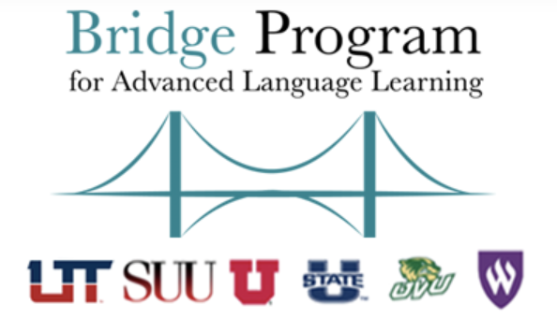

Utah Chinese Bridge Program

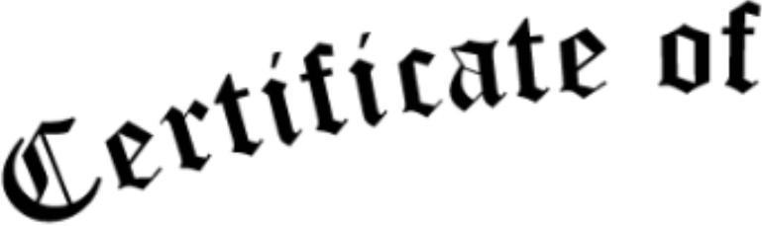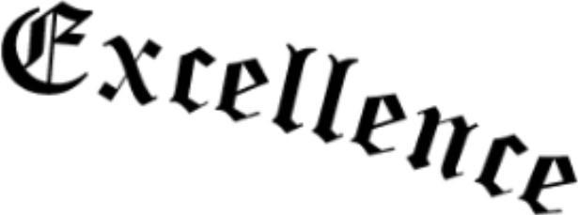

This Certificate of Excellence is Proudly presented to:

Student's Name

For successfully completing

**CHIN 3116, CHIN 3117, and CHIN 3118**

through the Utah Bridge Program at [-------------- High School]

Given This [17th Day of May, 2025]

 

Shin Chi Fame Kao

University of Utah Chinese Bridge Instructor

Patty Chung

Corner Canyon High School Chinese Teacher